Your Prayers-Lifeline to Dying Souls
August 1st, 2021

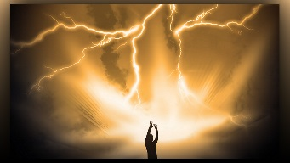
May the Lord bless you dear Heartdwellers and give you His peace. Mother Clare began, just before the community started to pray the Rosary, I wasn’t feeling well, when I heard Blessed Mother say, “This is an offering you know. So many are needed right now, thank you.”

Thank you for telling me that Mother, I sometimes forget.

Mother Mary continued, “The only message I have for you is keep up the good work with your prayers. Keep an eye on sloth and brushing off prayers to work. This is not pleasing to the Lord. However, you can pray while you work.”

Yes, I was going to ask you about that.

Should I let the men work through the three o’clock hour?
Mother please, I do not want to answer this, truly I want to know what you have to say.

Just then I pulled up a Rhema that said, “He who does not carry His cross and follow Me cannot be My Disciple.”

Blessed Mother continued, “I think that hour would be acceptable to the Lord if you really concentrated on the prayer while you were working. This is not as easy as it sounds. There are many temptations to bring up other things. But if you feel right in your conscience that you can do this, go ahead and try. Be honest with yourselves and if it fails then go back to concentrated prayer.

“Remember your one prayer could save a drowning mother, or aunties and uncles from being caught in a landslide. Only the Good Lord knows when is the hour of death. You can be a light unto the nations if you sacrifice what is your agenda to apply yourself to His when you are called.

“Be honest beloved ones, be honest. Remember, you are throwing a life line to a dying soul who does not know the Lord. Truly you are. Your prayers matter very much, your sufferings even more, times are hard now Clare, and much determination and strength are required to pass through them, especially those in India who are experiencing renewed persecution on a level never seen before.

“Do you see dearest daughter, do you see? The world is coming apart at the seams and My Son is going to rejuvenate it some day in the future. But for now, these are the times of taking down, this is the season of the death of all that is unholy. You must witness this and what you write will be to the benefit of those who need to understand.” And that was the end of Our Lady’s message.

God bless you dear ones and let us continue praying especially for the sick, the dying and the unprepared for death.

